More Polar and Parametric Equations

2004B BC1 (calculator allowed)

A particle moving along a curve in the plane has position  at time *t*, where

 and 

for all real values of *t*. At time *t = 0*, the particle is at the point *(4, 1)*.

(a) Find the speed of the particle and its acceleration vector at time *t = 0*.

(b) Find an equation of the line tangent to the path of the particle at time *t = 0*.

(c) Find the total distance traveled by the particle over the time interval 

(d) Find the *x-*coordinate of the particle at time *t = 3*.

2002 BC1 (calculator allowed)

A particle moves in the *xy*-plane so that at any time *t*, for  is given by  and  

(a) Sketch the path of the particle in the *xy*-plane provided. Indicate direction of motion along the path.

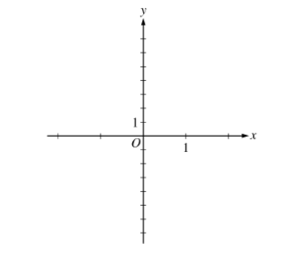

(b) Find the range of *x(t)* and the range of *y(t)*.

(c) Find the smallest positive value for *t* for which the *x*-coordinate of the particle is a local minimum. What is the speed of the particle at this time?

(d) Is the distance traveled by the particle from  to  greater than  Justify your answer.

2009B BC4 (no calculator)

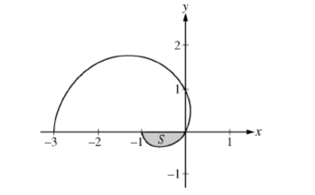

The graph of the polar curve  for  is shown above. Let *S* be the shaded region in the third quadrant bounded by the curve and the *x*-axis.

(a) Write an integral expression for the area of *S*.

(b) Write expressions for  and  in terms of 

(c) Write an equation in terms of *x* and *y* for the line tangent to the graph of the polar curve at the point where  Show the computations that lead to your answer.

2005 BC 2 (calculator allowed)

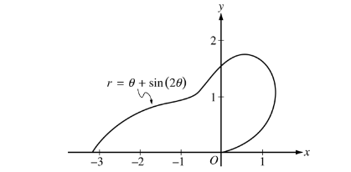

The curve above is drawn in the *xy*-plane and is described by the equation in polar coordinates  for  where *r* is measured in meters and  is measured in radians. The derivative of *r* with respect to  is given by 

(a) Find the area bounded by the curve and the *x*-axis.

(b) Find the angle  that corresponds to the point on the curve with *x*-coordinate *-2.*

(c) For   is negative. What does this fact say about *r*? What does this fact say about the curve?

(d) Find the value of in the interval  that corresponds to the point on the curve in the first quadrant with the greatest distance from the origin.

2004 BC3 (calculator allowed)

An object moving in the *xy*-plane has position  at time  with  The derivative  is not explicitly given. At time *t =2*, the position of the object is *(1, 8)*.

(a) Find the *x-*coordinate of the position of the object at time *t = 4*.

(b) At time *t = 2*, the value of  is *-7*. Write an equation for the line tangent to the curve at the point 

(c) Find the speed of the object at time *t = 2*.

(d) For  the line tangent to the curve at has a slope of *2t + 1*. Find the acceleration vector of the object at time *t = 4*.

2003 BC4 (no calculator allowed)

A particle moves in the *xy*-plane so that the position of the particle at any time *t* is given by  and 

(a) Find the velocity vector for the particle in terms of *t*, and find the speed of the particle at time *t =0*.

(b) Find  in terms of *t*, and find .

(c) Find each value *t* at which the line tangent to the path of the particle is horizontal, or explain why none exists.

(d) Find each value *t* at which the line tangent to the path of the particle is vertical, or explain why none exists.

1992 BC3 (calculator)

At time *t*,  the position of a particle moving along the *xy*-plane is given by the parametric equations  and 

a) Find the slope of the path of the particle at time 

b) Find the speed of the particle when 

c) Find the distance traveled by the particle along the path from  to 

1995 BC1 (calculator

Two particles move in the *xy*-plane. For time  the position of particle A is given by  and  and the position of particle B is given by  and 

a) Find the velocity vector for each particle at time 

b) Set up an integral expression that gives the distance traveled by particle A from  to  Do not evaluate.

c) Determine the exact time when the particles collide; that is, when the particles are at the same point at the same time. Justify your answer.

d) Sketch the path of the particles A and B from  until they collide. Indicate the direction of each particle along the graph.

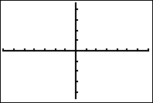

1998 BC6 (calculator)

A particle moves along the curve defined by the equation  The *x*-coordinate, *x(t)*, satisfies the equation  for  with the initial condition 

a) Find *x(t)* in terms of *t*.

b) Find  in terms of *t*.

c) Find the location and the speed of the particle at time 

1999 BC1 (calculator)

A particle moves along the *xy*-plane so that its position at any time *t*,  is given by  and 

a) Sketch the path of the particle. Indicate the direction of motion.



b) At what time *t*,  does *x(t)* attain its minimum value. What is the position  of the particle at this time?

c) At what time *t*,  is the particle on the *y*-axis? Find the speed and acceleration vector of the particle at this time?