More Integral Applications

2003 AB3 (calculator allowed)

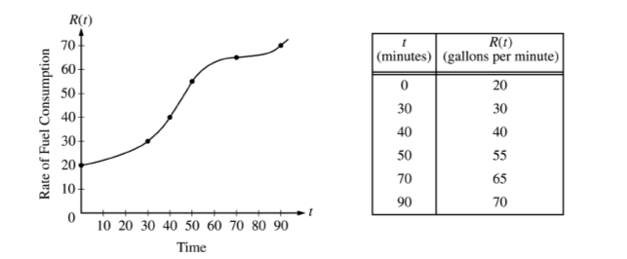

The rate of fuel consumption, in gallons per minute, recorded during an airplane flight is given by a twice-differentiable and strictly increasing function of time *t*. The graph *R* and a table of selected values of *R(t)*, for the time interval  minutes, are shown above.

(a) Use data from that table to find an approximation for  Show the computation that lead to your answer. Indicate units of measure.

(b) The rate of fuel consumption is increasing fastest at *t = 45* minutes. What is the value  of Explain your reasoning.

(c) Approximate the value of  using a left Riemann sum with the five subintervals indicated by the data in the table. Is this approximation less than the value of  Explain your reasoning.

(d) For  minutes, explain the meaning of  in terms of fuel consumption for the plane. Explain the meaning of  in terms of fuel consumption for the plane. Indicate units of measure in both answers.

2004 AB2 (calculator allowed)

The tide removes sand from Sandy Beach at a rate modeled by the function *R*, given by



A pumping station adds sand to the beach at a rate modeled by function *S*, given by



Both *R(t)* and *S(t)* have units of cubic yards per hour and *t* is measured in hours for  At time *t = 0*, the beach contains 2500 cubic yards of sand.

(a) How much sand will the tide remove from the beach during this 6-hour period? Indicate units of measure.

(b) Write an expression for *Y(t)*, the total number of cubic yards of sand on the beach at time *t*?

(c) Find the rate at which the total amount of sand on the beach is changing at time *t = 4*.

(d) For  at what time *t* is the amount of sand on the beach a minimum? What is the minimum value? Justify your answers.

2003B AB4 (calculator allowed)

A tank contains 125 gallons of heating oil at time *t = 0*. During the time interval  hours, heating oil is being pumped into the tank at the rate of

 gallons per hour.

During the same interval, heating oil is being removed from the tank at the rate of

 gallons per hour.

(a) How many gallons of heating oil are pumped into the tank during the time interval hours?

(b) Is the level of heating oil in the tank rising or falling at time *t = 6* hours? Give a reason for your answer.

(c) How many gallons of heating oil are in the tank at time *t = 12* hours?

(d) At what time *t*,  is the volume of heating oil in the tank the least? Show that analysis that leads to your conclusion.