12.2 Quadratic Functions Test Review
Part II - Working with Functions
Intercept/Factored Form:
- Find the roots/x-intercepts and describe the concavity
$$y=(x+4)(2x-5)$$ | $$y=-3(x+1)(x+10)$$

- Find the vertex
$$y=(x-4)(x-10)$$ | $$y=-3(x+1)(x-5)$$

Standard Form:
- Find the y-intercept and describe the concavity
$$y=3x^{2}+7x-19$$ | $$y=x^{2}-5x+2$$

Vertex Form:
- Graph Precisely and Analyze
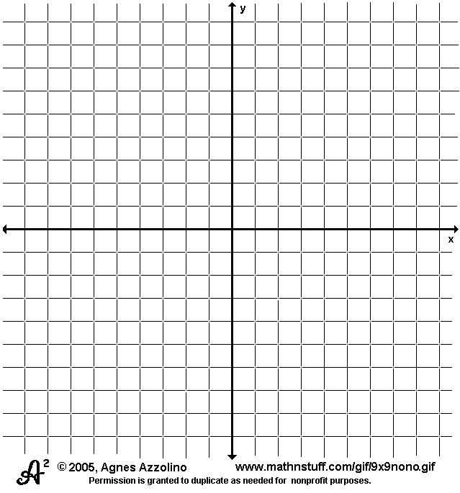  $y={\left(x-3\right)}^{2}-5$  Vertex:  (max or min?)  Axis of symmetry: | $y={-2\left(x+1\right)}^{2}+5$  Vertex:  (max or min?)  Axis of symmetry:
Domain Range  Increasing on Decreasing on  y-intercept: | Domain Range  Increasing on Decreasing on  y-intercept:

- Rewrite in vertex form, then sketch the graph
$$y=(x+3)(x+1)$$  This is in ___________________ form to begin with…. | $$y=2x^{2}-20x+10$$  This is in __________________ form to begin with….

