1.2 Homework
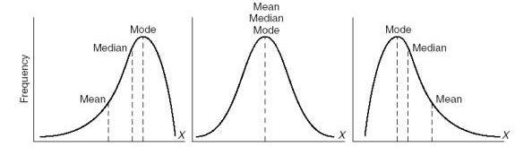
“Skewed Left” “Symmetric” “Skewed Right”
This frequency graph shows the monthly spending of a group of students on their cell phones.
This graph shows a range of spending of about ____________________.
I know this from the graph because _____________________________________________________________________
__________________________________________________________________________________________________.

The mode is about ____________________.
I know this from the graph because _____________________________________________________________________
__________________________________________________________________________________________________.

The median is about ____________________.
I know this from the graph because _____________________________________________________________________
__________________________________________________________________________________________________.

Most students spend over ____________________.
I know this from the graph because _____________________________________________________________________
__________________________________________________________________________________________________.

