1.2 Homework

Graph the following
- $y=\left\{\begin{aligned}x-3, -4≤ x<2 \\ -\frac{1}{2}x+6, 2<x≤6\end{aligned}\right.$
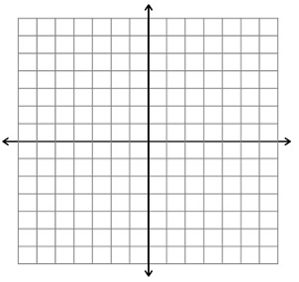
Domain: Increasing on:

Range: Decreasing on:

Positive on: Constant on:

Negative on: roots:

Graph the absolute value functions by plotting the vertex, then using the slopes
- $y=2\left|x-1\right|-5$  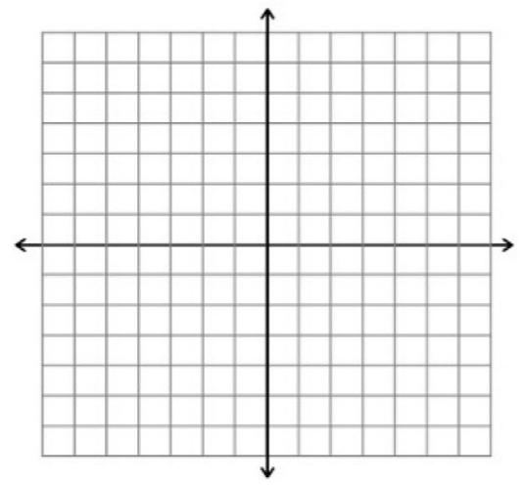  Vertex:  Slopes: | - $y=-\left|x+4\right|+6$  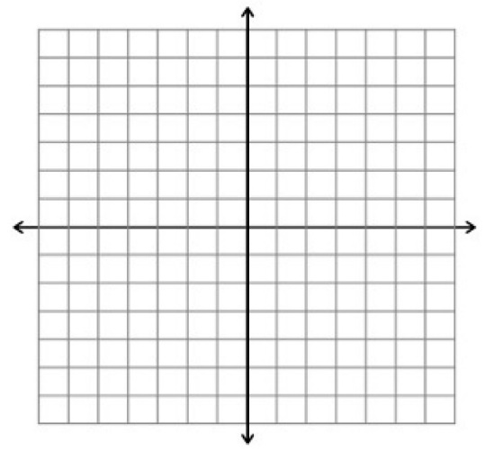  Vertex:  Slopes:
Solve the absolute value equation by graphing
- $-\left|x\right|+4=-3$  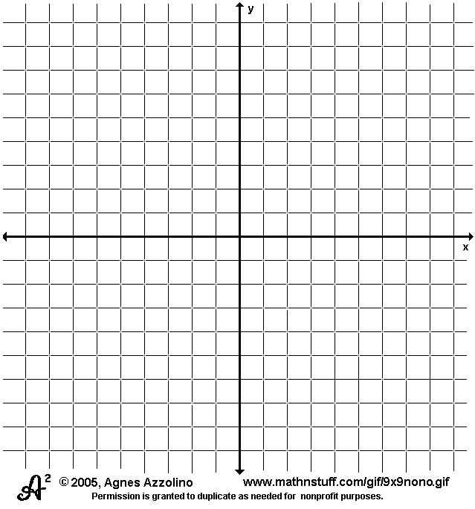  Solution: x =  Plot: | - $\frac{1}{2}\left|x+1\right|=4$  Solution: x =  Plot:
Quiz tomorrow on the topics on this page

