1.1 Homework
Graph the following
- $y=\left\{\begin{aligned}4, x<-2 \\ -\frac{3}{2}x+1, -2<x<5\end{aligned}\right.$  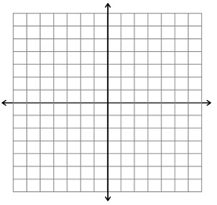  Domain:  Range: | - $y=\left\{\begin{aligned}x-3, -3≤x<2 \\ -2x+6, 2≤x≤4\end{aligned}\right.$  Domain:  Range:
- $y=-\frac{1}{2}|x|$  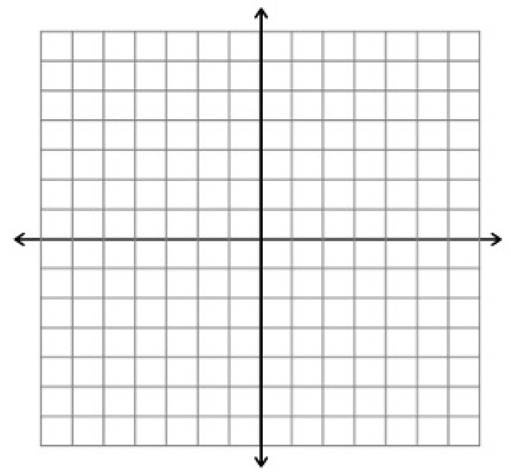  Vertex:  Domain:  Range: | - $y=2\left|x\right|-5$  Vertex:  Domain:  Range:
- $y=\left|x-5\right|$  Vertex:  Domain:  Range: | - $y=\left|x-2\right|-5$  Vertex:  Domain:  Range:

